**SQL Questions**

* **Basic Select Query:**
  + **Question:** Retrieve all details of customers who have placed orders.
  + **Task**: Write a SQL query to join the customers and orders tables and select relevant customer details

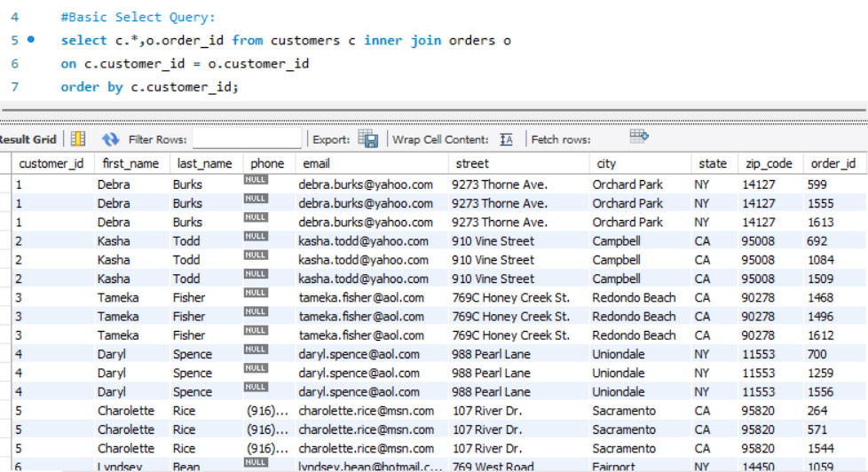

* **Aggregate Functions:**
  + **Question:** Calculate the total sales for each store.
  + **Task**: Use aggregate functions like SUM and GROUP BY to calculate total sales from the orders and order_items tables

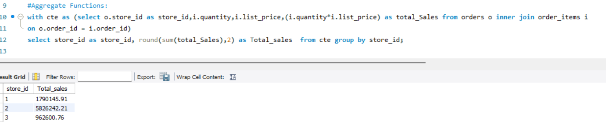

* **Subqueries:**
  + **Question:** Find the products that have never been ordered.
  + **Task:** Write a subquery to identify products in the products table that do not appear in the order_items table

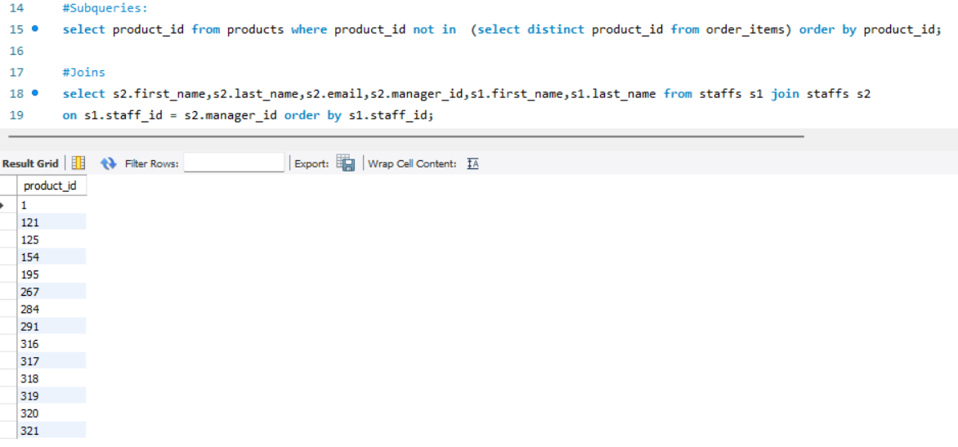

* **Joins:**
  + **Question:** Retrieve the names and email addresses of staff along with the names of their managers.
  + **Task:** Write a SQL query to join the staffs table with itself to get staff and their manager information

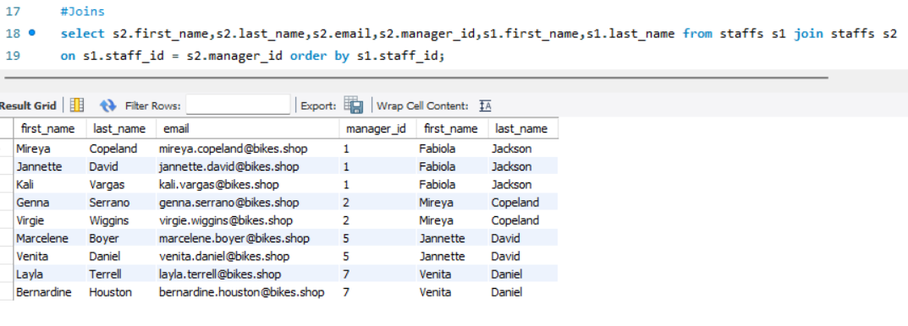

* **Window Functions:**
  + **Question:** Rank stores based on their total sales.
  + **Task:** Use window functions like ROW_NUMBER() or RANK() to rank stores based on total sales

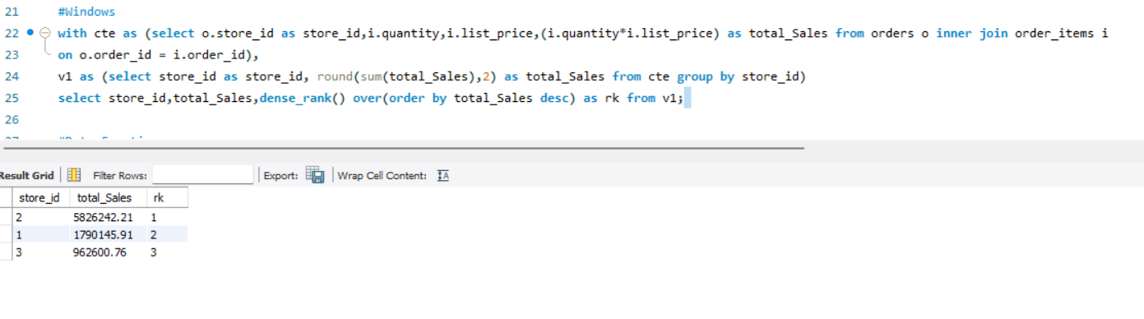

* **Date Functions:**
  + **Question:** Calculate the number of days each order took to ship.
  + **Task:** Use date functions to calculate the difference between shipped_date and order_date in the orders table

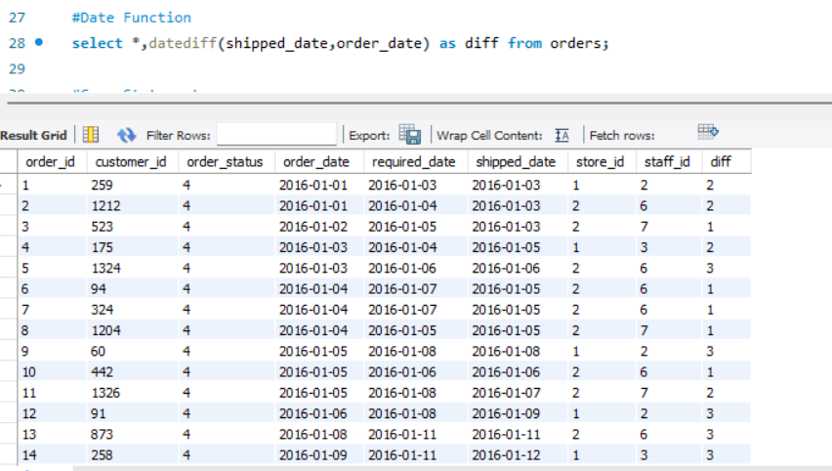

* **Case Statements:**
  + **Question:** Categorize orders based on their status.
  + **Task:** Use CASE statements to categorize orders in the orders table into different status groups.

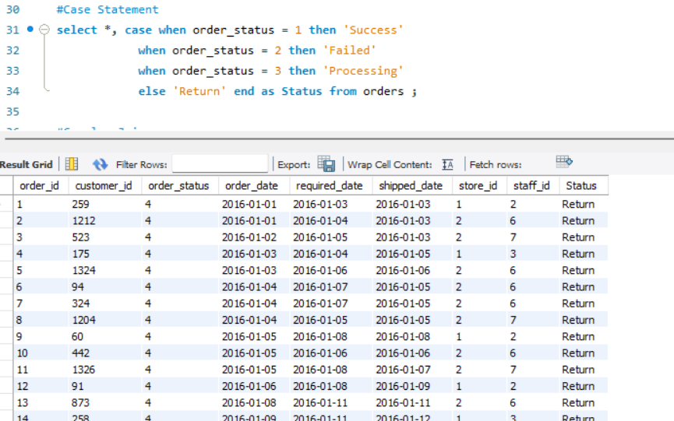

* **Complex Joins:**
  + **Question:** Retrieve all orders along with the product names and the store names.
  + **Task:** Write a SQL query to join the orders, order items, products, and stores tables

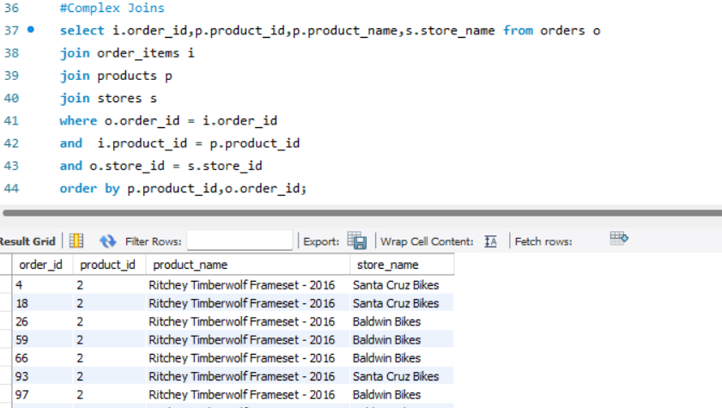

* **Temporary Tables:**
  + **Question:** Create a temporary table to store intermediate sales calculations.
  + **Task:** Use CREATE TEMPORARY TABLE to store results of a complex calculation for further analysis.

